# Cancelling Purchase Orders - Trouble shooter

Purchase Orders that are ‘Open Order’ and will never be progressed (receipted/invoiced) *need* to be **cancelled**. There are 2 ways to cancel a PO, either by clicking the cancel button at the top, or by cancelling the deliver remainder on the line.

## Using the Cancel button on the PO

At the top of a PO you will see a Cancel button:

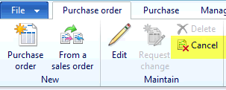

This button will be active only if the PO has at least 1 open line, and if that PO is Confirmed. This is the easiest option when cancelling a PO, so if you can, click the cancel button and the PO should move to **Cancelled** or **Invoiced** status depending on other lines on the PO. If it is greyed out, move onto the next option.

## Cancelling the deliver remainder

Within a PO (double click on the PO from the list page), there is an action bar above the lines:



You must select a line that has a value in the “Delivery Remainder” field:

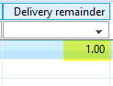

Once you have selected the line, click on the Update line action from the action bar and then click ‘Deliver remainder’:

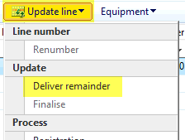

Once the popup loads, click ‘Cancel quantity’. This will remove the quantity in the ‘Open order’ field and set this line to **Cancelled**.

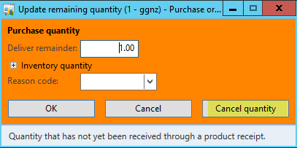

If you get an error after clicking the Cancel quantity button, there will be a transaction behind the scenes that is either registered or picked. This will need to be investigated before fixing. Please email the Service Desk with the error and the PO number if this happens.

After you successfully click the Cancel quantity button, the line will be cancelled, if this is the only or last line that had a Deliver remainder, the PO will change to **Cancelled** or **Invoiced**.

*If there is any pertinent information around the history or reasoning with the Purchase Order, it would be very helpful for future reference to add this information as a note to the attachments on the PO.*

To add an attachment, click on the ‘Attachments’ button at the top of the Purchase Order.



Then click ‘New’ and ‘Note’.

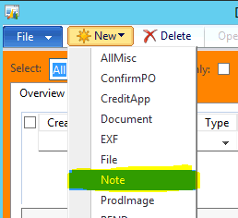

Enter in a Description and then type out more info if required.

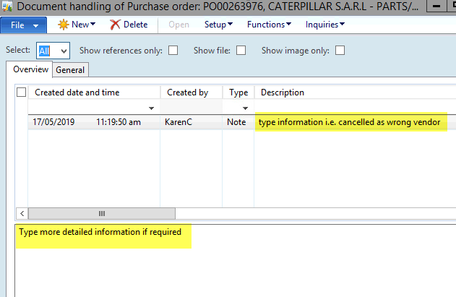

Then click the close button.



## Cancelling an Open Order PO that has no Lines

If your Purchase Order has no lines, you will not be able to cancel it, as there is nothing to cancel! To cancel a PO that has no lines, you must add a line. Once you have added the line, simply follow the steps to cancel the deliver remainder above. You do not need to confirm or submit it for this to happen.

## Everything else

If none of these options help you get the PO cancelled, please email the Service Desk with the PO number and mention that you need help cancelling the PO.